# Git Assignment-2

## Create a Git working directory with feature1.txt and feature2.txt in the master branch

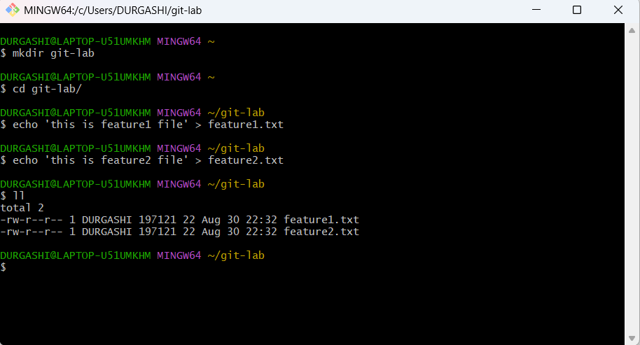

## Create 3 branches develop, feature1 and feature2

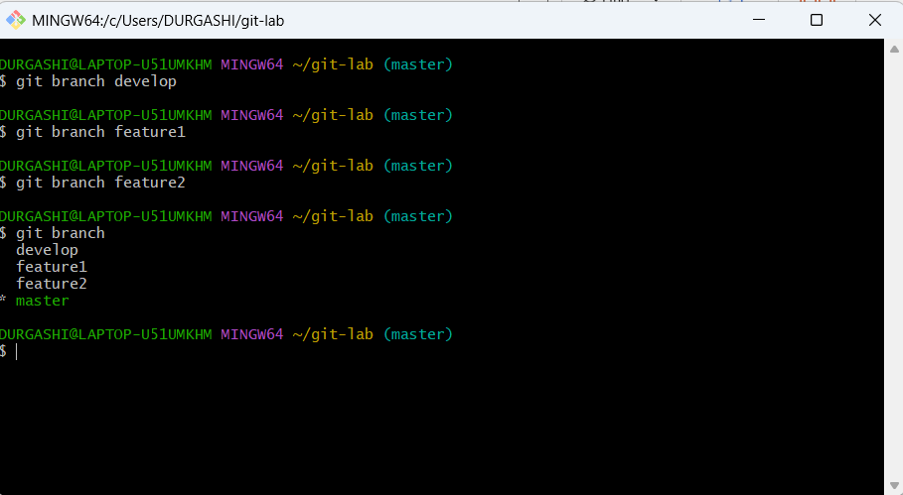

## In develop branch create develop.txt, do not stage or commit it

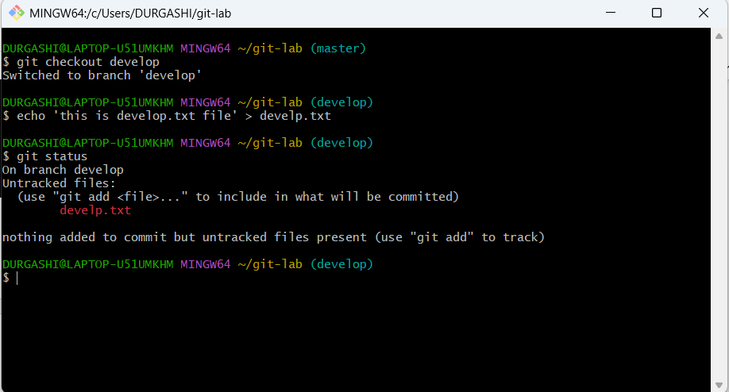

## Stash this file and check out to feature1 branch

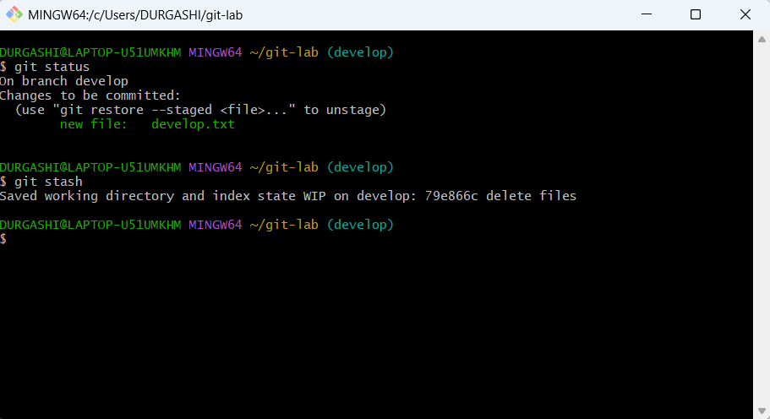

## Create new.txt file in feature1 branch, stage and commit this file

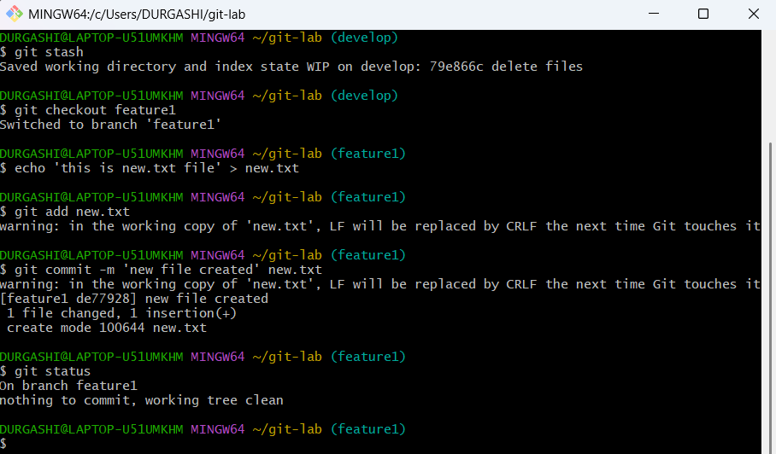

## Checkout to develop, unstash this file and commit

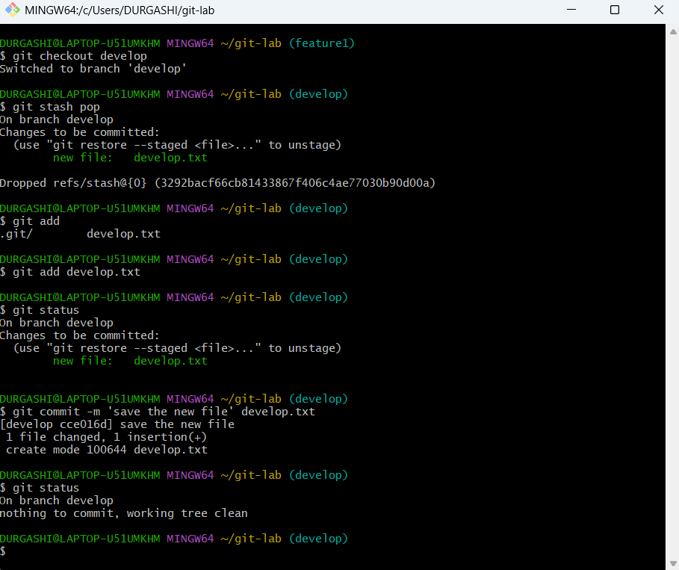

## Please submit all the Git commands used to do the above steps

mkdir git-lab

cd git-lab/

echo 'this is feature1 file' > feature1.txt

echo 'this is feature2 file' > feature2.txt

git init

git branch develop

git branch feature1

git branch feature2

git branch

git checkout develop

echo 'this is develop.txt file' > develp.txt

git status

git stash develop.txt

git checkout feature1

echo 'this is new.txt file' > new.txt

git add new.txt

git commit -m 'new file created' new.txt

git status

git checkout develop

git stash pop

git add develop.txt

git commit -m 'save the new file' develop.txt

git status